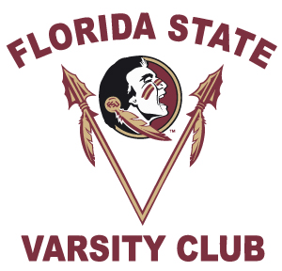
50th Anniversary of Women’s Athletics
Women’s Track & Field Reunion Registration
March 22nd, 2019
PLEASE PRINT For Office Use Only: Re Acct: Fund Id: ________

First Name Last Name

Mailing Address
( )
City State Zip Code Home Phone Number

( ) ( )
Cell Phone Number Business Phone Number

***E-mail Address – Required for Confirmations***

I am a former Florida State University Track Member:
Please circle: Player Coach Trainer Manager Staff
Years participated: _________________________________(i.e. 1979-1980)_______

PLEASE CHECK ALL THAT APPLY:
_____ I will attend the 50th Anniversary of Women’s Athletics Track & Field Reunion at the FSU Relays on Friday, March 22nd, 2019.
- # of Guests ________
- Names of Your Guests _____________________________________________

_____ I will attend the 50th Anniversary of Women’s Athletics Track & Field On – The – Field Recognition.

PLEASE RETURN BY March 8, 2019

Betsy Hosey, Varsity Club, P.O. Box 1353, Tallahassee, FL 32302
Ph. (850) 644-1123 · E-mail: bhosey@.fsu.edu

