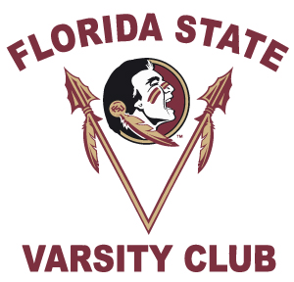
PLEASE PRINT For Office Use Only: Re Acct: __ Fund Id: 70218
1999 National Championship Reunion Registration
October 25th & 26th, 2019

First Name Last Name
Mailing Address
( )
City State Zip Code Home Phone Number
( ) ( )
Cell Phone Number Business Phone Number

***E-mail Address – Required for Confirmations***

I am a former Florida State University football:
Please circle: Player Coach Trainer Manager Staff
Years participated: _________________________________(i.e. 1997-1999)_______
PLEASE CHECK ALL THAT APPLY:
_____ I will attend the reception at the FSU Varsity Club on Friday, October 25th.
- # of Guests ________
- Names of Your Guests _____________________________________________

_____ I would like to attend the football gathering at the Indoor Practice Facility on Saturday, October 26th.

_____ I will need my two (2) complimentary football tickets.

_____ I will need _____ additional FSU vs. Syracuse Football Tickets at $25 each.
Please Go To: www.seminoles.com to purchase your additional football tickets online.
1. Click On Tickets.
2. Click on Buy Tickets Now.
3. Scroll to 2019 Football. Click on 2019 Single Game Tickets. Click in PROMO CODE box.
4. Enter Promo Code: WIRE2WIRE and begin purchasing your tickets.

If you do not have access to a computer. Please make check payable to FSU Ticket Office and return with this Registration form.

My Shirt Size is:

PLEASE RETURN BY October 1st, 2019
Betsy Hosey, Varsity Club, P.O. Box 1353, Tallahassee, FL 32302
Ph. (850) 644-1123 · E-mail: bhosey@.fsu.edu

