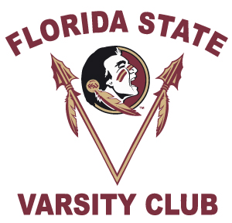
1987-1990 Football
Reunion Registration
October 19th & 20th, 2018
PLEASE PRINT For Office Use Only: Re Acct: Fund Id: 70218

First Name Last Name
Mailing Address
( )
City State Zip Code Cell or Contact Phone Number
My Shirt Size is:

***E-mail Address – Required for Confirmations***

I am a former Florida State University football:
Please circle: Player Coach Trainer Manager Staff
Years participated: _________________________________(i.e. 1979-1980)_______
PLEASE CHECK ALL THAT APPLY:
_____ I will attend the reception at the FSU Varsity Club on Friday, October 19th.
- # of Guests ________
- Names of Your Guests _____________________________________________

_____ I would like to attend the football gathering at the Indoor Practice Facility on Saturday, October 20th.

_____ I will need my two (2) complimentary football tickets.

_____ I will need _____ additional FSU vs. Wake Forest Tickets at $20 each.
Please Go To: www.seminoles.com to purchase your additional football tickets online.
1. Click On Tickets.
2. Click on Buy Tickets Now.
3. Scroll all the way to the bottom and look for Special Packages. Click on PROMO CODE.
4. Enter Promo Code: FB8790 and begin purchasing your tickets.

If you do not have access to a computer. Please make check payable to FSU Ticket Office and return with this Registration form.

PLEASE RETURN BY October 1, 2018

Betsy Hosey, Varsity Club, P.O. Box 1353, Tallahassee, FL 32302
Ph. (850) 644-1123 · E-mail: bhosey@.fsu.edu

