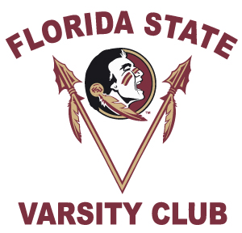
PLEASE PRINT For Office Use Only: Re Acct: Fund Id: ________
1967-1991 Metro Championship Women’s Track & Field Reunion Registration
October 21st & 22nd, 2017

First Name Last Name
Mailing Address
( )
City State Zip Code Home Phone Number
( ) ( )
Cell Phone Number Business Phone Number

***E-mail Address – Required for Confirmations***

I am a former Florida State University football:
Please circle: Player Coach Trainer Manager Staff
Years participated: _________________________________(i.e. 1979-1980)_______
PLEASE CHECK ALL THAT APPLY:
_____ I will attend the reception at the FSU Varsity Club on Friday, October 21st.
- # of Guests ________
- Names of Your Guests _____________________________________________

_____ I would like to attend the Track & Field gathering at TBD on Saturday, October 22nd.

_____ I will need my two (2) complimentary football tickets.

_____ I will need _____ additional FSU vs. Louisville Football Tickets at $45 each.
Please Go To: www.seminoles.com to purchase your additional football tickets online.
1. Click On Tickets.
2. Click on Buy Tickets Now.
3. Click on PROMOTION CODE tab.
4. Enter Promo Code: TRACK and begin purchasing your tickets.

If you do not have access to a computer. Please make check payable to FSU Ticket Office and return with this Registration form.

My Shirt Size is:

PLEASE RETURN BY September 20, 2017

Betsy Hosey, Varsity Club, P.O. Box 1353, Tallahassee, FL 32302
Ph. (850) 644-1123 · E-mail: bhosey@.fsu.edu

